The ‘Un’usual Thing!

The IUPAC name all elements after 100 with the initials ‘un’ and I, being a science student, could never really miss the opportunity to pay a tribute to them, though in an unusual manner. Coz, being usual is too mainstream!

Here, we wander over some of the most unusual things I walked upon

Okay, let’s make some categories:

1. Phones- in today’s age nothing seems right without this life companion. So let’s look at a few of them

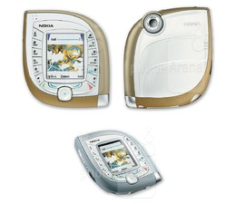NOKIA 7600-- It’s been 11 years since Nokia launched the 7600 (as its second 3G-capable phone), and the handset is still a rare sight to behold. Of course, its bulky, leaf-like design made it uncomfortable to hold in hand, but customers who bought it probably didn’t do it because of the phone’s ergonomics anyway. The 7600 had a 2-inch display with 128 x 160 pixels, and a VGA camera.

1. 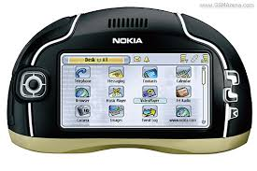NOKIA 7700- The Nokia 7700 is like an upside-down N-Gage. It doesn’t have a proper keypad, instead featuring a 3.5-inch touchscreen display with 640 x 320 pixels, and a stylus. The 7700 was announced n 2003, but Nokia cancelled its release the following year - so the handset was never sold.
2. 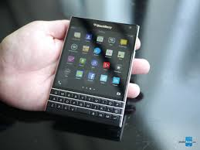BLACKBERRY PASSPORT-The BlackBerry Passport's bullish focus on productivity spawns a fantastic keyboard, but its blocky shape makes one-handed use difficult.

Moving on to some other categories,

Let’s talk about some really weird cafes or restaurants in our country

1. New Lucky Restaurant in Ahmadabad, India,

# It's dead in here! Restaurant owner in India places tables around coffins after opening business on site of old cemetery

* The cafe in Ahmadabad, India has flourished since opening at old cemetery
* Coffins are sealed off by iron grills and lie inside the restaurant
* Owner Krishnan Kutti claims it gives customers 'a unique experience'
* 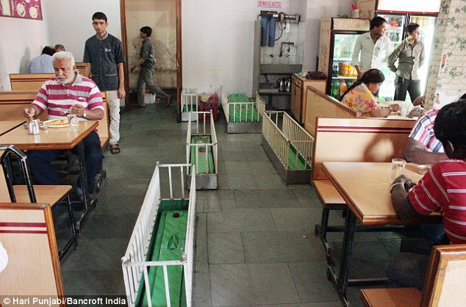Graves thought to belong to followers of 16th Century Sufi saint

## The Jail - Jail Theme Andheri West, Mumbai

Want to experience jail food? Then head on to this jail theme joint. The recreation of a jail is commendable and this jail food will cost a good thousand rupees for you and your partner.

1. Machaan restaurant, Kolkata

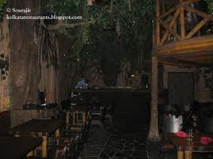

Maachan, a unit of mainland china group is a unique experience.

A big grey elephant and tribal men with spears and gears pique interest

As you come inside through main entrance-you enter to a jungle instead

Of a restaurant .The place in dark with dense jungle foliage covering

Most of the space and for company you have an elephant , giraffes

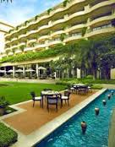Crocodiles and monkey, parrots, squirrels, bears and an anaconda! staring

at you

1. OASIS RESTAURANT( VIVANTA BY TAJ), HARYANA

The flavour of food from the land of the five rivers is out. Dig in and be delighted. Get down to earth, as the elements combine. Themes of soil, water, fire, charcoal and the forest stake claim on the menu to reflect the infusion of nature on the plate in Paranda. Smell the flavours, feel the textures, hear the sounds of the landscape from where they were drawn. Enjoy the fine art of robust Punjabi cooking here.

Buildings and monuments have always enthralled us and it’s time to enjoy these unusual structures:

1.National-Fisheries-Development-Board

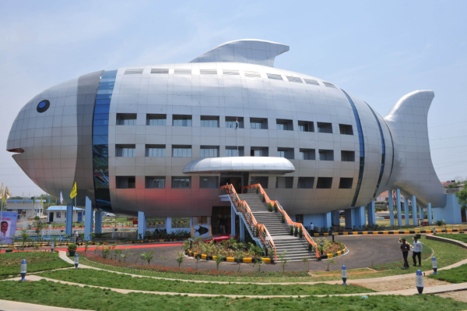The newly constructed National Fisheries Development Board (NFDB) regional office building at Rajendranagar in Hyderabad, India, was inaugurated by Chief minister Kiran Kumar Reddy and Indian Agriculture Minister Sharad Pawar on April 20, 2012.

2. EDRC CHENNAI

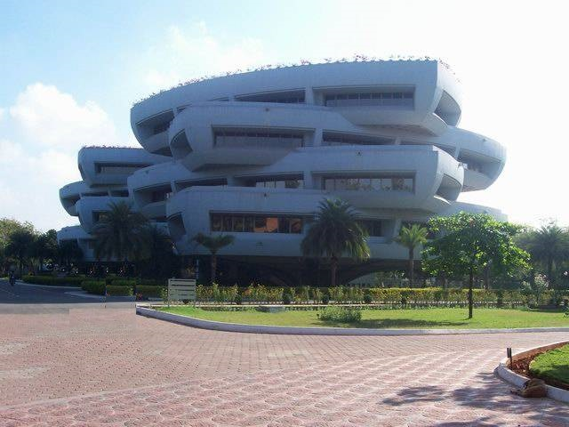EDRC is the second building in India and the second one in Chennai to get this rating under LEED-EB category. The EDRC building is ranked first among the list of top amazing green corporate offices in India.

3. Infosys Pune

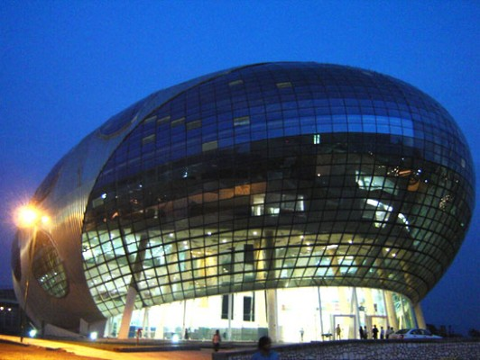The Infosys Pune campus has one of the most unique building design the Egg-shaped building. Infosys Headquarters building of Hinjewadi Pune is a beautiful high-tech building,actually looks like a descending spacecraft.